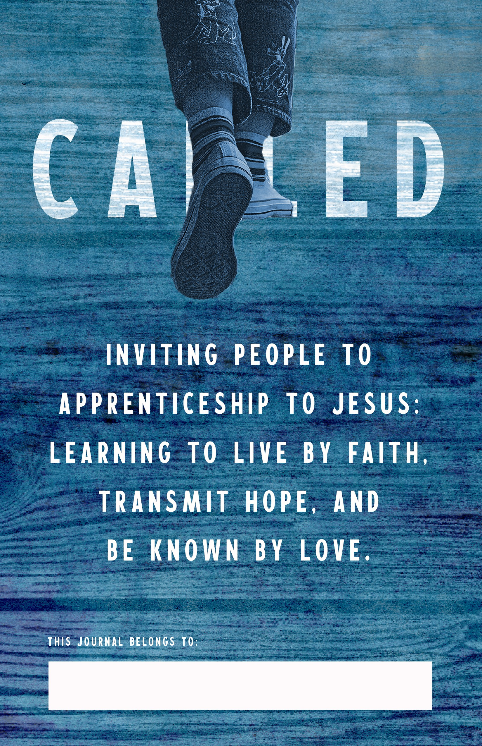

Week 1: Apprenticeship
September 6-12
- If you could learn one thing from Jesus what would it be?

- If Jesus were living your life how would it
look different?
- What do you think it means to be an ap- prentice to Jesus?

- Activity: Before you go to bed, think about your day and think about when you lived like Jesus and when you didn’t.

Apprentice of Jesus: someone learning to live their life as
4 Jesus would lead it if he were them..
Apprentice of Jesus: someone learning to live their life as Jesus would lead it if he were them. 5

Week 2: Worshiping
September 13-19
- How would you describe someone who is a worshiper?

- How could you be a better worshiper?
- Do you think it’s more powerful to worship by yourself or with a group of people? Why?

- Activity: When you come to worship service spend some time preparing yourself to worship before hand.

Live by faith: trusting and believing the ways of Jesus lead to
6 eternal life.
Live by faith: trusting and believing the ways of Jesus lead to
eternal life. 7

Week 3: Learning
September 20-26
- Would you say that you are a good learner? Why or why not?

- What are you learning about God?
- How do you think Jesus was a learner?

- Activity: Find a video on YouTube that teaches you how to make a paper airplane!

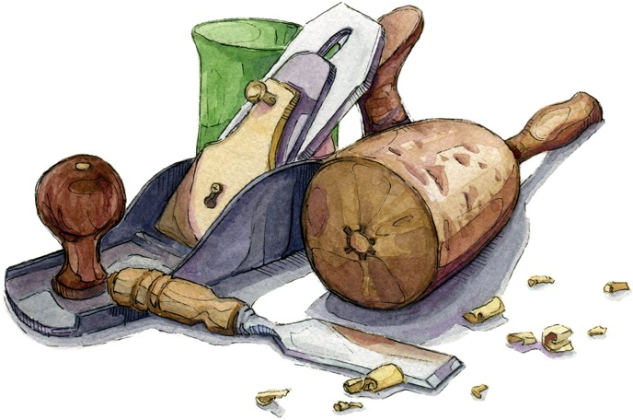

Live by faith: trusting and believing the ways of Jesus lead to
8 eternal life.
Live by faith: trusting and believing the ways of Jesus lead to
eternal life. 9

Week 4: Generous
September 27 - October 3
- How has Jesus been generous?

- What do you think is different from God’s
generosity then the world’s generosity?
- When was the last time you experienced generosity?

- Activity: Seek to be generous this week to someone at school.

Live by faith: trusting and believing the ways of Jesus lead to
10 eternal life.
Live by faith: trusting and believing the ways of Jesus lead to
eternal life. 11

Week 6: Serving
October 11-17
- What do you think it means to serve?

- Do you have a regular place to serve either at church, school or home?
- How did Jesus serve?

- Activity: Look for ways to serve in more ways than you usually do.

Transmit hope: proclaiming and demonstrating the reality
12 and goodness of life with God
Transmit hope: proclaiming and demonstrating the reality
and goodness of life with God 13

Week 7: Cross-Cultural
October 18-24
- What do you think it means to live a cross- cultural life?

- How do you think Jesus lived a cross- cultural life?
- Why do you think it’s important to live a cross-cultural life? How did Jesus serve?

- Activity: Find a YouTube video that talks
about the culture of a different country.

Transmit hope: proclaiming and demonstrating the reality
14 and goodness of life with God
Transmit hope: proclaiming and demonstrating the reality
and goodness of life with God 15

Week 8: Sharing
October 25-31
- What are ways you can share your faith with others?

- Is it normal for you to talk about God? Why or why not?
- Read Matthew 28:18-20, what is Jesus’ promise to us as we go out and share our faith with other?

- Activity: Invite a friend to come to church with you.

Transmit hope: proclaiming and demonstrating the reality
16 and goodness of life with God
Transmit hope: proclaiming and demonstrating the reality
and goodness of life with God 17

Week 10: Knowing
November 8-13
- What do you think it means to be authentic?

- Are the group of friends you have a good
influence on you? Why or why not?
- Do you think it is important for people to know you and you to know them? Why or why not?

- Activity: Talk to someone you trust about something you are having a hard time with.

Known by love: recognize the dignity in one another leading
18 to selfless servanthood.
Known by love: recognize the dignity in one another leading
to selfless servanthood. 19

Week 11: Mentoring
November 15-21
- What adults have had a positive influence
on your life?

- Is there anyone younger than you in your life that you could help?
- What do you think it means to mentor?

- Activity: Write an adult in your life a thank you note saying how grateful you are for them.

Known by love: recognize the dignity in one another leading
20 to selfless servanthood.
Known by love: recognize the dignity in one another leading
to selfless servanthood. 21

Week 12: Reconciling
November 22-28
- What does it mean to reconcile?

- Have you experienced reconciliation before?
- Why do you think reconciliation is a big deal to God?

- Activity: Reach out to someone you may have issues with and try to resolve and rec- oncile.

Known by love: recognize the dignity in one another leading
22 to selfless servanthood.
Known by love: recognize the dignity in one another leading
to selfless servanthood. 23

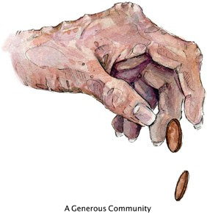“Inviting People to Apprenticeship to Jesus: learning to live by faith,
transmit hope,
and be known by love.”

Crossroads Church of God
775 S. Thayer Rd Lima, OH 45806
419-229-4074
www.limacrossroads.org
Sundays at 9 & 10:45 am Online at 10:45am

